QUIZ 5
1. a) mean price = 19800
Standard deviation = 300
P(X<19445) = P (Z< (19445 – 19800)/300) = P (Z<-1.1833) = 0.1183
b) P(X< 20300) = 1- P(X<20300) = 1- P (Z<1.6667) = 1- 0.9522 = 0.0478
c) For lower 5%, z = -1. 6449
Hence corresponding value = 19800 – 1.6449*300 = 19306.53

2. a) in first case, sample size is greater than 30 but less than 5% of the population, that is, 2500. So use the formula $σ$_{z} = $σ$/$\sqrt{n}$
$σ$_{z} = $σ$/$\sqrt{n}$ = 50/$\sqrt{1500}$ =1.29
b) In second case, sample size is greater than 30 but greater than 5% of the population, that is, more than 2500. So use the formula $σ$_{z}=$σ$/$\sqrt{n}$ [$\sqrt{(N}-n)/(N-1)$]
$σ$_{z}= $σ$/$\sqrt{n}$ [$\sqrt{(N}-n)/(N-1)$] =$50/√4000$[$\sqrt{(50000}-4000$)/(50000 -1)] =0.76

3. Given mean (µ) = 2300 sq. ft.
Standard deviation $(σ)$ = 450sq ft
Sample size (n) – 25
To find mean and standard deviation of the sampling distribution of x-bar
When mean and standard deviation of population is given then sample mean= ϰ
And sample standard deviation is $σ$/$√n$
Therefore mean of the sampling distribution of x-bar =2300 sq. ft. and standard deviation = $σ$/$\sqrt{n}$
= 450/$√25$ =450/5 = 90 sq. ft.
4. Standard deviation = 0.25
And for 99% level; z=2.3263
As we know that z score = (X- mean)/standard deviation
2.3263 = (20 – mean)/0.25
Mean = 20 – 0.25*3.3263 = 19.4184
5. Let X be the circumference of balls.
Given that X follows a normal distribution with mean = µ = 9.125and standard deviation = $σ$ = 0.06.
Then Z = (X – µ)/ $σ$ = (X – 9.125)/0.06 follows standard normal
P (9<X<9.25) =P(X<9.25)-P(X<9)
=P [(x-9.125)/0.06< (9.25-9.125)/0.06]-P[(x-9.125)/0.06<(9-9.125)/0.06]
=P (Z<2.08)-P (Z<-2.08)
=0.9812-0.0188
=0.9624
Required percentage = 1- 0.9624 =0.0376 = 3.76%$√$
6. Given µ=mean=150, $σ$ =26lbs for a right standard deviation
a) x-bar= µ =15= for n=45
$σ$ _{s}= $σ$ /$√n$ =26/$√45$ =26/3$√5$
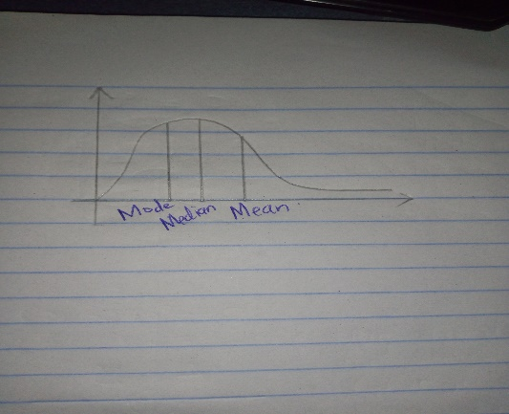
At $σ$ value the skewness decreases and it approaches symmetric
b) We cannot find the probability for this sample that x-bar> 160 (x-bar= µ=150 do not match)
Therefore P(x-bar > 160) =0
c) For n=15, x-bar= µ=150, $σ$ _{s}= $σ$ /$\sqrt{n}$ = 25/$√15$
d) P(x-bar >160) = 0 [for n=15, 30, 45, any value]
7. a) here, mean = 0.88 and standard deviation = (P(1-P)/n)1/2 = 0.0363
The shape will be approximately normal as sample size is greater than 30 as well as np>10 and n (1-P) > 10
b) P(X<0.82) = P(Z<(0.82-0.88)/0.0363) = P(Z<-1.6514) = 0.0493

